The NBI - The Neethling Brain Instrument
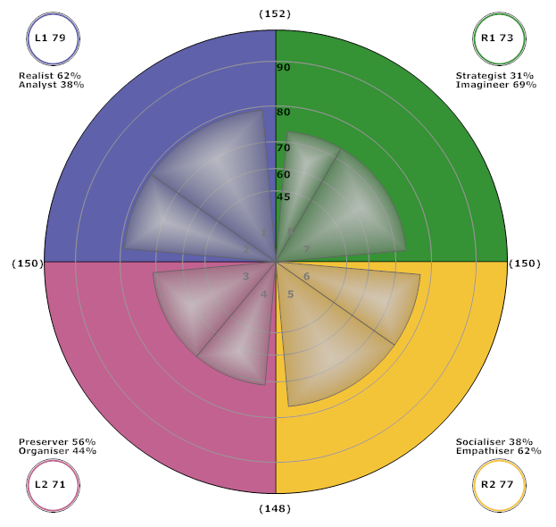
The Neethling Brain Instrument (NBI™) as a source of reliable information on thinking preferences and the concepts of whole brain thinking.

What is a Whole Brain NBI profile?
The NBI® is a 30-question diagnostic survey developed to measure thinking preferences. Gaining insight into the way we prefer to think makes us more aware of and sensitive to the preferences of others.

The NBI results include four quadrant brain profile as well as a second 8 Dimensions brain profile result (see sample) providing insights into an individual's thinking preferences.

Developing better relationships, making more dynamic contributions in the team and making sound and relevant decisions are but a few of the advantages of understanding your own thinking profile.
NBI results are neither good nor bad. The NBI® provides a profile of thinking preference which is a descriptive, objective analysis of the individual's thinking choices, with no profile being better or worse than another. A downloadable .pdf guide to an NBI Whole Brain profile is here.

Who is Kobus Neethling?
Dr. Neethling, acknowledged as one of 500 “Leaders of Influence” by the American Biographical Institute, leads NBI with unparalleled passion.

Facts about the NBI

NBI is based on scientific study by Dr. Kobus Neethling based on the profiling of more than 200,000 adults and children from a number of countries, after almost 30 years of extensive international research on left and right-brain functions. Ongoing research at a number of universities and institutes remains an essential part of whole brain science at present. More about the NBI is available here on this FAQ's and via the links below.

Adapted from sources:
http://www.nbiprofile.com/ and http://www.wholebrainthinking.com.au/nbi.htm

